

# PROJECT: GROUP NO: BATCH:

# SYSTEM REQUIREMENTS:

1. **Hardware**:

**Web Server**

* Processor Intel Core I3 or higher.
* Memory 6 GB RAM or greater.
* Modem/ADSL Internet access is required.

**Client**

* Processor Intel Core I3 or higher.
* Memory 6 GB RAM or greater.
* Monitor Super VGA (1024x768) or higher resolution.
* Modem/ADSL Internet access is required.

1. **Software**:

**Server:**

* Web server: XAMPP
* Operation System: Window 7 or later.
* Databases: MySQL.
* PHP - Laravel framework
* Browser: Google Chrome version 35.
* Git

**Client:**

* Operation System Window 7 or higher.
* Browser Google Chrome , MS-Edge, Firefox

# Program Instrallation

1. **Install with easycar.rar file:**

Step 1. Copy file easycar.rar to directory Disk(C,D,..):\xampp\htdocs

Step 2. Extract easycar.rar file in this folder.

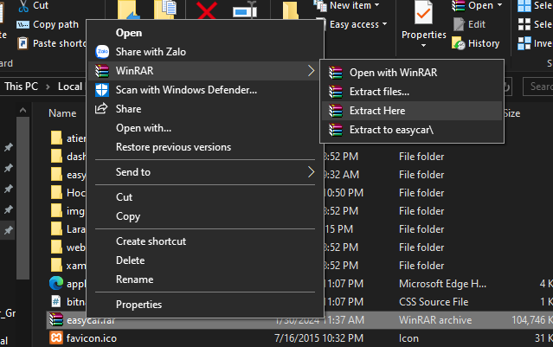

Step 3 . - The project uses phpmySQL server, so it needs a server containing a database named "easycar" for you to test run the project. Here I use XAMPP to create a local server (port 83 for Apache and 3306 for MySQL)

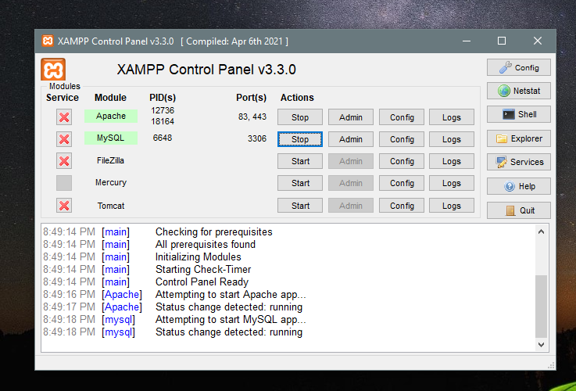

Step 4. Create a database name “easycar” in MySQL Server (phpMyAdmin) , then import file easycar.sql to this database.

Step 5. Access to url: **localhost:83/easycar** to run the project

1. **Download from GitHub:**

Step 1. In htdocs, right click and select Open Git Bash here.

Step 2. Run the following command:

git clone <https://github.com/VietVu1398/EasyCar_Group1>

Rename folder “EasyCar_Group1” to “easycar”. In folder “seasycar”,

right click and select Open Git Bash here, then run following command:

composer install

cp .env.example .env

php artisan key:generate

Then continue install step 3,4,5 in (I) .

...........

# C. Successful test

- The file is loaded successfully

- Homepage should be displayed as described in the documentation.



* Additional

Login account, use one of the following accounts:

|  |  |
| --- | --- |
| **Username** | **Password** |
| admin01@gmail.com(admin) | 12345678 |
| moderator01@gmail.com(moderator) | 12345678 |
| user01@gmail.com(user) | 12345678 |

Payment VNPAY info for check:

|  |  |
| --- | --- |
| **Ngân hàng** | NCB |
| **Số thẻ** | 9704198526191432198 |
| **Tên chủ thẻ** | NGUYEN VAN A |
| **Ngày phát hành** | 07/15 |
| **OPT** | 123456 |

(Lưu ý sau khi thanh toán, VNPAY sẽ trả về địa chỉ localhost:83, các máy đang chạy trên cổng localhost khác có thể sẽ gặp lỗi)